//Controller CLass

package com.cognizant.orm_learn.Controller;  
  
import com.cognizant.orm_learn.Service.CountryService;  
import com.cognizant.orm_learn.Service.exception.CountrynotFoundException;  
import com.cognizant.orm_learn.model.Country;  
import org.springframework.beans.factory.annotation.Autowired;  
import org.springframework.http.ResponseEntity;  
import org.springframework.web.bind.annotation.*;  
  
import java.util.List;  
  
@RestController  
@RequestMapping("/countries")  
public class CountryController {  
  
 @Autowired  
 private CountryService countryService;  
  
 @GetMapping("/countries")  
 public List<Country> getAllCountries() {  
 return countryService.getallcountries();  
 }  
 @GetMapping("/{code}")  
 public ResponseEntity<?> getcountrubycode(@PathVariable String code){  
 try{  
 Country country=countryService.findCountryByCode(code);  
 return ResponseEntity.*ok*(country);  
 } catch (CountrynotFoundException e) {  
 return ResponseEntity.*status*(404).body(e.getMessage());  
  
 }  
 }  
 @PostMapping  
 public Country addcountry(@RequestBody Country country){  
 System.*out*.println("Received from Postman: " + country);   
 return countryService.addCountry(country);  
 }  
  
  
}

// Model clas

package com.cognizant.orm_learn.model;  
  
import com.fasterxml.jackson.annotation.JsonProperty;  
import jakarta.persistence.Column;  
import jakarta.persistence.Entity;  
import jakarta.persistence.Id;  
import jakarta.persistence.Table;  
  
@Entity  
@Table(name = "country")  
public class Country {  
  
 @Id  
 @Column(name = "co_code")  
 @JsonProperty("code")  
 private String code;  
  
 @Column(name = "co_name")  
 @JsonProperty("name")  
 private String name;  
  
 public String getCode() {  
 return code;  
 }  
  
 public void setCode(String code) {  
 this.code = code;  
 }  
  
 public String getName() {  
 return name;  
 }  
  
 public void setName(String name) {  
 this.name = name;  
 }  
  
 @Override  
 public String toString() {  
 return "Country(code=" + code + ", name=" + name + ")";  
 }  
}

//Service Class

package com.cognizant.orm_learn.Service;  
  
import com.cognizant.orm_learn.Service.exception.CountrynotFoundException;  
import com.cognizant.orm_learn.model.Country;  
import com.cognizant.orm_learn.repository.CountryRepository;  
import jakarta.transaction.Transactional;  
import org.springframework.beans.factory.annotation.Autowired;  
import org.springframework.stereotype.Service;  
import org.springframework.web.bind.annotation.GetMapping;  
import org.springframework.web.bind.annotation.PostMapping;  
import org.springframework.web.bind.annotation.RequestBody;  
  
import java.util.List;  
import java.util.Optional;  
  
@Service  
public class CountryService {  
 @Autowired  
 private CountryRepository countryRepository;  
 public CountryService(CountryRepository countryRepository) {  
 this.countryRepository = countryRepository;  
 }  
  
  
  
  
 public List<Country> getallcountries(){  
 return countryRepository.findAll();  
 }  
 @Transactional  
 public Country findCountryByCode(String countryCode) throws CountrynotFoundException {  
 Optional<Country> result = countryRepository.findById(countryCode);  
 if (!result.isPresent()) {  
 throw new CountrynotFoundException("Country with code " + countryCode + " not found.");  
 }  
 return result.get();  
 }  
  
 public Country addCountry(Country country) {  
 System.*out*.println("Saving: " + country);  
 return countryRepository.save(country);  
 }  
  
  
}

///Exception class

package com.cognizant.orm_learn.Service.exception;  
  
public class CountrynotFoundException extends Exception{  
 public CountrynotFoundException(String message){  
 super(message);  
 }  
}

/ MAIN CLASS

package com.cognizant.orm_learn;  
  
import com.cognizant.orm_learn.Service.CountryService;  
import com.cognizant.orm_learn.model.Country;  
import org.slf4j.Logger;  
import org.slf4j.LoggerFactory;  
import org.springframework.boot.SpringApplication;  
import org.springframework.boot.autoconfigure.SpringBootApplication;  
import org.springframework.context.ApplicationContext;  
  
import java.util.List;  
  
@SpringBootApplication  
public class OrmLearnApplication {  
  
 private static final Logger *LOGGER* = LoggerFactory.*getLogger*(OrmLearnApplication.class);  
 private static CountryService *countryService*;  
  
 public static void main(String[] args) {  
 ApplicationContext context = SpringApplication.*run*(OrmLearnApplication.class, args);  
 *countryService* = context.getBean(CountryService.class);  
 *testGetAllCountries*();  
 }  
  
 private static void testGetAllCountries() {  
 *LOGGER*.info("Start");  
 List<Country> countries = *countryService*.getallcountries();  
 *LOGGER*.info("countries={}", countries);  
 *LOGGER*.info("End");  
 }  
}

///Test Clas

package com.cognizant.orm_learn.service;  
  
import com.cognizant.orm_learn.Service.CountryService;  
import com.cognizant.orm_learn.model.Country;  
import com.cognizant.orm_learn.repository.CountryRepository;  
import org.junit.jupiter.api.Test;  
import org.springframework.beans.factory.annotation.Autowired;  
import org.springframework.boot.test.context.SpringBootTest;  
  
import java.util.List;  
  
import static org.junit.jupiter.api.Assertions.*;  
  
@SpringBootTest  
public class CountryServiceTest {  
  
 @Autowired  
 private CountryService countryService;  
  
 @Test  
 public void testGetAllCountries() {  
 List<Country> countries = countryService.getallcountries();  
 *assertNotNull*(countries);  
 *assertTrue*(countries.size() > 0, "Country list should not be empty");  
  
 for (Country country : countries) {  
 System.*out*.println(country);  
 }  
 }  
}

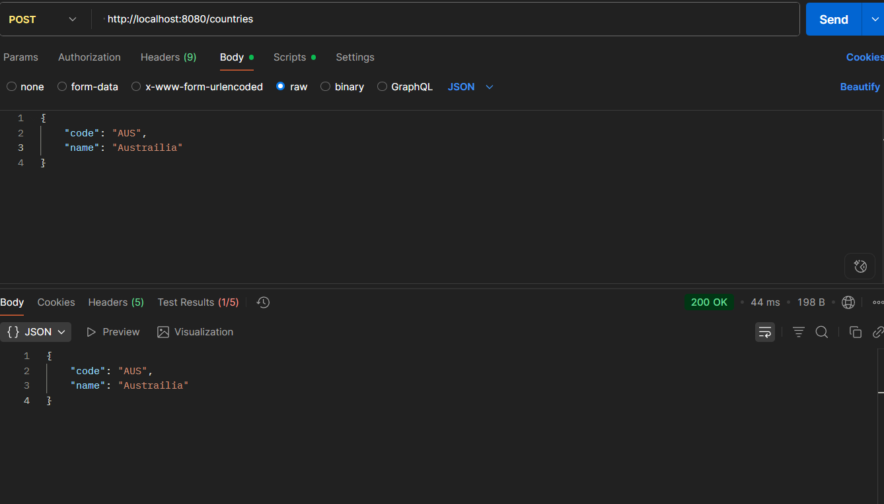//output

